IELTS General Training Writing sample task – Task 2
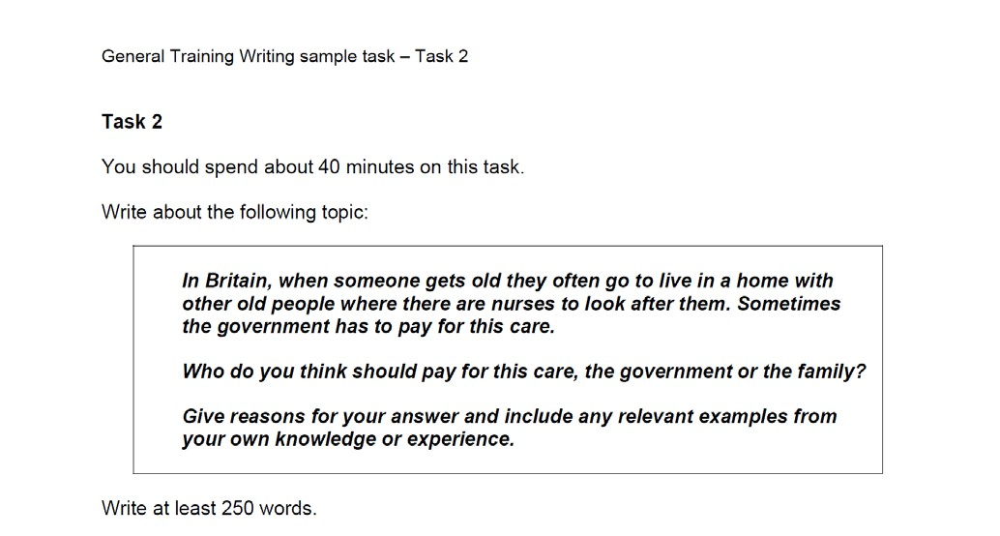

IELTS General Writing Task 2: Worksheet 1

Part 1 – The introduction

Advances in medical science, healthier diets and better living conditions are helping us live longer than ever. Consequently more and more elderly people require specialist accommodation such as care homes and this can be expensive. This raises the question of whether these services should be financed by the state or by the closest relatives of the old person.

……………………………………….. fold here ……………………………………………………………

Some people believe that children’s leisure activities must be educational, otherwise they are a complete waste of time.
Do you agree or disagree?

Give reasons for your answer and include any relevant examples from your knowledge or experience.

……………………………………….. fold here ……………………………………………………………

Advances in technology mean that children have a huge array of new and exciting ways to spend their free time. But these activities are sometimes criticised by those who claim that children cannot learn anything valuable from them. This raises the question of whether children’s hobbies and pastimes have to have an educational value, or whether they simply need to be entertaining.

IELTS General Writing Task 2: Worksheet 2

Paragraph 1

One of the main reasons why the government should bear the financial burden of care homes is cost. Most families simply could not afford the high price of the accommodation and nursing provided by these institutions. If the state stopped providing these services, most old people who need specialist care would be forced to remain in unsuitable accommodation.

Paragraph 2

However, cost is also a significant reason why families should at least contribute to the payment of care home fees.

IELTS General Writing Task 2: Worksheet 3

One of the main reasons why the government should bear the financial burden of care homes is cost. Most families simply could not afford the high price of the accommodation and nursing provided by these institutions. If the state stopped providing these services, most old people who need specialist care would be forced to remain in unsuitable accommodation.

Provided …

Unless …

Should …

Were …

